Dean McCullough

Images for the web
ICTWeb305

Contents
Logo Design 2
Banner Design 3
Advertisement 4
Copywrite and Licence 5
References 5

Request of digital design
Student Design
Dean McCullough
Ellengowan Dr, Casuarina NT 0810

16/08/2023

KK Racing
Ken Kalashnikov.
GPO Box 442, Darwin 0800

Dear Ken,

We have received your request for some new marketable images for your online image.

Please find attached a logo design, Twitter banner design, an Instagram post design, and some information on copywrite.

We hope these designs can help improve your social media image and look forward to hearing back from you.

Sincerely

Mr. McCullough
Student at CDU

Logo Design
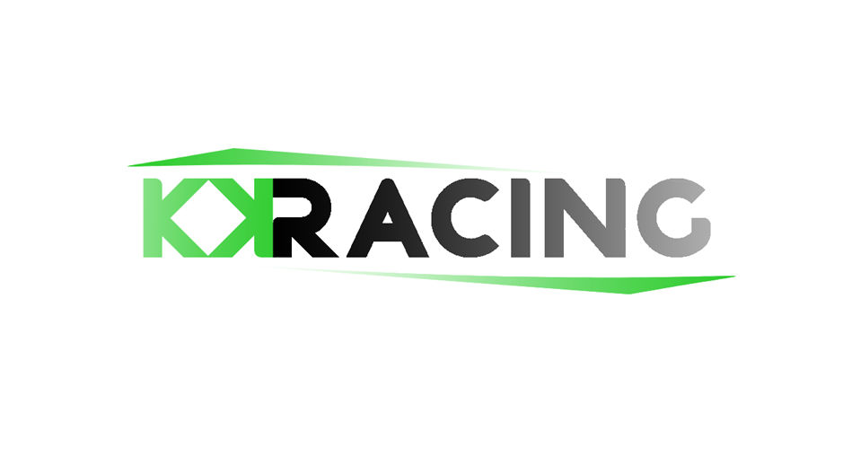
Information:
Resolution: 1280x720 (Standard HD)
Dpi: 72 pixels
I have landed on this logo design. I’ve tried to keep the image simple and eye catching. The simplicity will allow more people to recognize the logo and become familiar with it. This is a common theme for car racing logos.
I used a bright green colour to match the green car you drive and faced the KK towards each other making them feel connected.
I added the vector lines at the top and bottom to help catch the eye but kept them smaller and smooth to avoid taking away from the text.

Banner Design
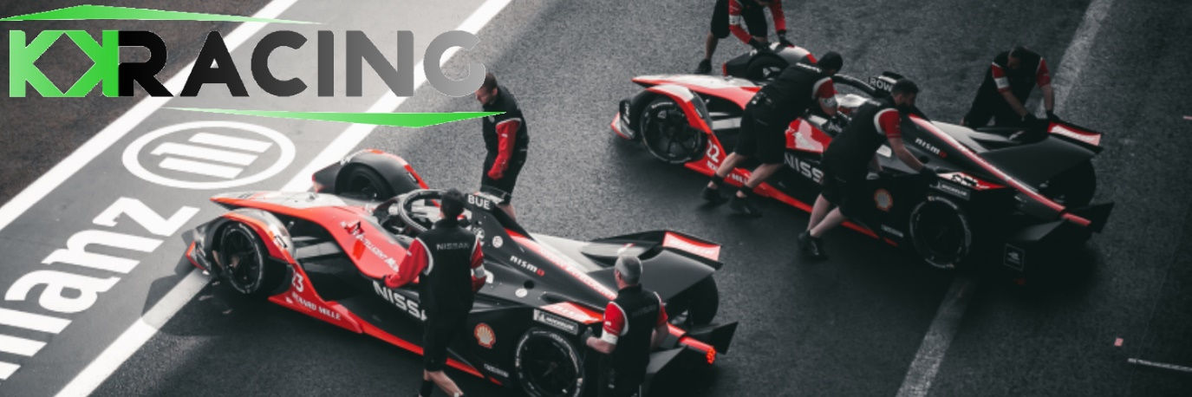
Information:
Pixels: 1500x500 (Standard Twitter banner)
DPI: 72 pixels
After researching multiple banners, it was common to continue with simplicity using stock imagery that looks good. I chose this photo as it looks like a team working together for a common goal and willing to do the hard work together.
I kept the logo in the top left to avoid the profile picture covering it and to continue to reinforce the logos meaning and for people to easily recognize your growing brand.

Advertisement
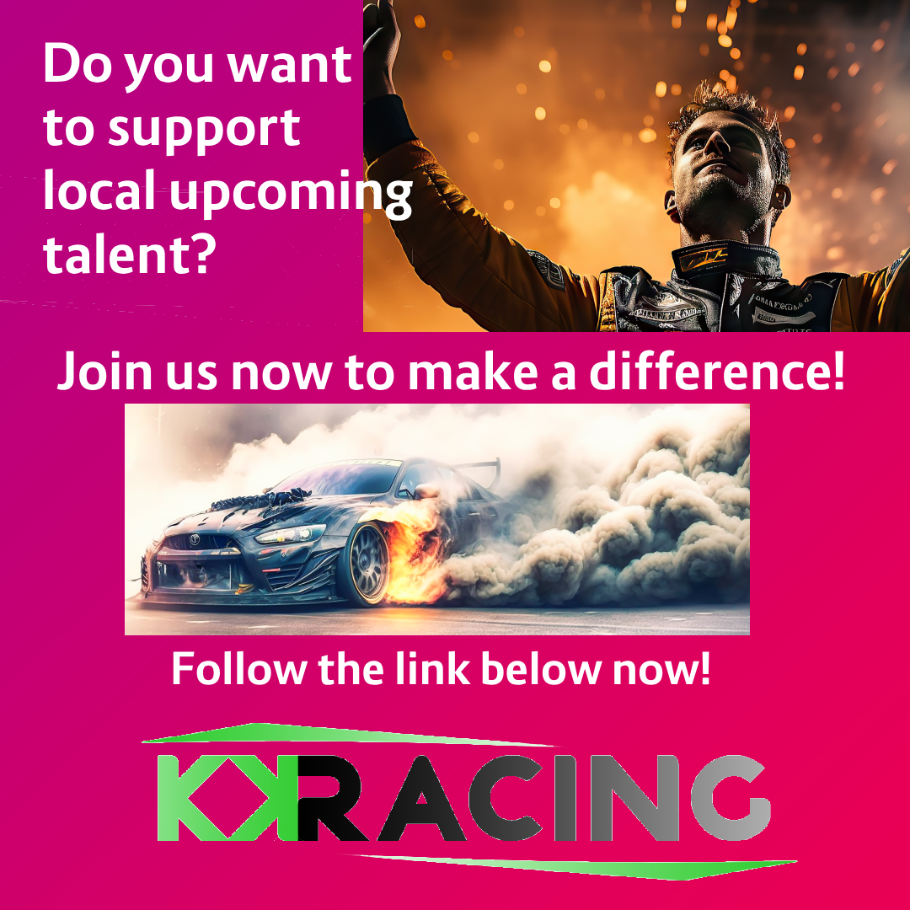
Information:
Resolution 1080x1080 (Standard Instagram post)
DPI: 72 pixels
As for the advertisement. As many Instagram users don’t spend lots of time looking at each post, I tried to use a mix of eye-catching imagery and short but communicative texts to try captivating the audience.
I used a smooth pink background as its nice and bright and used on Instagram. I also once again kept your logo at the bottom to continue and build repetition within your brand and make the logo more recognisable.
The text is plain and easy to read but also split up to make the reader work their way down seeing your logo and hopefully, your description bringing them closer to sponsoring. I used buzz words to try and give your audience more incentive to be involved.
Under the photo, you should include a description like:
Our mission is to support up and coming local talent. We strive to be the best and compete across the country.
No matter how large or small, your sponsorship is crucial to helping us make a meaningful impact on our community and future generations.
Help us make a difference by sponsoring us now. Contact us through [contact information]

Copywrite and Licencing

All images used in the above designs have been used lawfully in accordance with applicable licensing and have been referenced for all licencing and sources.
THE STUDENT DESIGN RELEASE FORM
I hereby grant KK Racing permission to use my designs highlighted here (“logo”, “banner”, advertisement”), in any and all of its publications, including web-based publications, without payment or other consideration.
I understand and agree that all photos will become the property of KK Racing and will not be returned.
I hereby irrevocably authorise KK Racing to edit, alter, copy, exhibit, publish, or distribute these photos for any lawful purpose in accordance with law. In addition, I waive any right to inspect or approve the finished product. Additionally, I waive any right to royalties or other compensation arising or related to the use of the photo.
I hereby hold harmless, release, and forever discharge Student Design from all claims, demands, and causes of action which I, my heirs, representatives, executors, administrators, or any other persons acting on my behalf or on behalf of my estate have or may have by reason of this authorization.

References
License from Pexels –
https://www.pexels.com/license/
Image used from Pexels –
https://www.pexels.com/photo/pit-crew-standing-beside-sports-cars-14401742/
Vecteezy Licensing agreement -
https://www.vecteezy.com/licensing-agreement
Images on Instagram advertisement -
- https://www.vecteezy.com/photo/25537128-formula-one-race-car-driver-celebrating-the-win-in-a-race-against-bright-stadium-lights-generative-ai
- https://www.vecteezy.com/photo/24542616-car-drifting-burning-tires-on-speed-track-generative-ai

©Student Design. All rights reserved.
©Student Design. All rights reserved.
©Student Design. All rights reserved.

